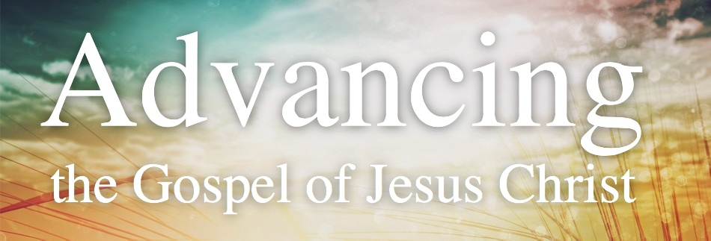

Week 2 – In & Thru My Church & Ministries
(7 Values from the Book of Acts & “Gospelize” by Greg Stier)

1 – Intercessory PRAYER Fuels It
Acts 1:14

2 – Relational EVANGELISM Drives It
Acts 18:26

3 – Leaders Fully EMBRACE & MODEL It
Acts 4:8-18

4 – A DISCIPLE MULTIPLICATION Strategy Guides It
Acts 19:8-10

5 – A BOLD VISION Focuses It
Acts 1:8

6 - BIBLICAL OUTCOMES Measure It
Acts 11:19-24

7 – Ongoing PROGRAMS REFLECT It
Acts 6:1-4

So What?!~
- DEEP

- WIDE

Week 2 – In & Thru My Church & Ministries
(7 Values from the Book of Acts & “Gospelize” by Greg Stier)

1 – Intercessory PRAYER Fuels It
Acts 1:14

2 – Relational EVANGELISM Drives It
Acts 18:26

3 – Leaders Fully EMBRACE & MODEL It
Acts 4:8-18

4 – A DISCIPLE MULTIPLICATION Strategy Guides It
Acts 19:8-10

5 – A BOLD VISION Focuses It
Acts 1:8

6 - BIBLICAL OUTCOMES Measure It
Acts 11:19-24

7 – Ongoing PROGRAMS REFLECT It
Acts 6:1-4

So What?!~
- DEEP

- WIDE

Til The Day I Die by Toby Mac

I'll keep swingin' for the fences
It's like this heart is defenseless
Against the passion that's pumpin' through my veins
Blood, sweat, tears, it's a callin'
And if I can't walk, then I'm crawlin'
It might flicker, but they can't kill the flame

I can't stop, I can't quit,
It's in my heart, It's on my lips
I can't stop, no I can't quit
It's in my heart, yeah I'm all in
Til the wheels fall off, Til the spotlight fades
I will lift your banner high, I will lift your banner high
And til the walls crash in, For the rest of my days
I'll lay it all on the line, Til the day I die

It's Your name I'll glorify
It's runnin' deeper than the ocean
This ain't religion, it's devotion
365, every minute, everyday
So in the middle of the madness
They can stretch me out like canvas
But I ain't ever gonna fit in their frame

Til I die and they put me in the coffin
Don't matter if I'm on the road or if I'm recordin'
Tell me what you think about me, that really ain't important
You know Imma represent um, I ain't playin', can't afford to
I only got one life and I get it though
And this is not an act, not a movie, not a TV show
I don't know what quittin' means, I don't ever take it slow
You know I'm on the grind, me and Toby in the studio
Do it for the King, what you know about that?
Say you goin' harder, mmm I doubt that'
You say you doin' work, but you're asking where the couch at
How you doin' work when you asking where the couch at?
God is not a crutch, you can use Him when you wanna
You only look to heaven when you goin' through some drama
And when they goin' through some problems
And that's the only time they call Him
I guess I don't understand that life, wonder why?
'Cause I'm ALL IN…….. Til the Day I Die
Til The Day I Die by Toby Mac

I'll keep swingin' for the fences
It's like this heart is defenseless
Against the passion that's pumpin' through my veins
Blood, sweat, tears, it's a callin'
And if I can't walk, then I'm crawlin'
It might flicker, but they can't kill the flame

I can't stop, I can't quit,
It's in my heart, It's on my lips
I can't stop, no I can't quit
It's in my heart, yeah I'm all in
Til the wheels fall off, Til the spotlight fades
I will lift your banner high, I will lift your banner high
And til the walls crash in, For the rest of my days
I'll lay it all on the line, Til the day I die

It's Your name I'll glorify
It's runnin' deeper than the ocean
This ain't religion, it's devotion
365, every minute, everyday
So in the middle of the madness
They can stretch me out like canvas
But I ain't ever gonna fit in their frame

Til I die and they put me in the coffin
Don't matter if I'm on the road or if I'm recordin'
Tell me what you think about me, that really ain't important
You know Imma represent um, I ain't playin', can't afford to
I only got one life and I get it though
And this is not an act, not a movie, not a TV show
I don't know what quittin' means, I don't ever take it slow
You know I'm on the grind, me and Toby in the studio
Do it for the King, what you know about that?
Say you goin' harder, mmm I doubt that'
You say you doin' work, but you're asking where the couch at
How you doin' work when you asking where the couch at?
God is not a crutch, you can use Him when you wanna
You only look to heaven when you goin' through some drama
And when they goin' through some problems
And that's the only time they call Him
I guess I don't understand that life, wonder why?
'Cause I'm ALL IN…….. Til the Day I Die

