A Great Nation

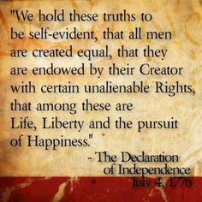
A Great Foundation

A Great Passion

A Great Mission

A Great Promise

So What ? !

A Great Humbling

A Great Nation

A Great Foundation

A Great Passion

A Great Mission

A Great Promise

So What ? !

A Great Humbling

